M O N T S E R R A T

MARRIAGE (AMENDMENT) ACT 2024

No. 14 of 2024

ARRANGEMENT OF SECTIONS

1. Short title 2
2. Interpretation 2
3. Section 15 amended 3
4. Section 36 amended 3
5. Section 46 amended 5
6. Section 47 amended 6
7. Section 55 amended 7
8. Section 62 amended 7
9. First Schedule amended 7

I ASSENT

Sgd. Sarah Tucker (Mrs.)
GOVERNOR
Sarah Tucker

DATE: 2 May 2024

M O N T S E R R A T

No. 14 of 2024

AN ACT to amend the Marriage Act (Cap. 5.01).

BE IT ENACTED by the King’s Most Excellent Majesty, by and with the advice and consent of the Legislative Assembly of Montserrat, and by the Authority of the same as follows:—
1. Short title
This Act may be cited as the Marriage (Amendment) Act, 2024.
2. Interpretation
In this Act, “principal Act” means the Marriage Act, (Cap. 5.01).
3. Section 15 amended
Section 15 of the principal Act is deleted and the following is substituted―
“15. Performance of marriage by Registrar-General
The Registrar-General may perform a function or act in respect of a marriage in his office or at a suitable place.”.
4. Section 36 amended
Section 36 of the principal Act is deleted and the following is substituted―
“36. Application for licences
(1) Persons intending marriage who desire to obtain a licence to marry shall apply to the Governor by petition in Form AA set out in the First Schedule.
(2) The petition shall state—
(a) the Christian or other names and surnames of the parties;
(b) the profession or occupation of the parties;
(c) whether the marriage is to be solemnized by a Marriage Officer or celebrated by the Registrar-General, the place where the marriage is to be solemnized or celebrated and the name of the Marriage Officer or Registrar-General;
(d) whether the parties or either of them have or has been previously married;
(e) that the parties know of no impediment of kindred or alliance or other lawful cause to prevent the proposed marriage;
(f) that at least one of the parties has been resident in Montserrat for at least three working days immediately preceding the date of application;
(g) that the consent of the person or persons whose consent to the marriage is required under this Act has been obtained; and
(h) any other information as may be required.
(3) The petition shall be signed by both parties and shall be accompanied by, in respect of each party―
(a) an original birth certificate;
(b) a copy of the photograph page of the party’s valid passport or a copy of the party’s driver’s licence or national identification card;
(c) if a party has never been married―
(i) a certificate of non-marriage or other written proof of non-marriage from a Register Office or similar office responsible for the registration of marriages in any country where the party has resided, from the age of eighteen years; or
(ii) a sworn statement before a notary public, Justice of the Peace, Commissioner for Oaths, minister of religion, judge or Registrar of the High Court that the party believes that there is no impediment of kindred or alliance or any other lawful cause to prevent the proposed marriage;

(d) if a party has been previously married, proof of the dissolution of the marriage;
(e) if a party is widowed, proof of marriage and proof of death of her husband or his wife;
(f) notarized consent of the person or persons whose consent to the marriage is required under this Act, if the party is under the age of eighteen years and is not a widow or widower;
(g) any other information required to support the petition; and
(h) a receipt evidencing payment of the fee payable for the grant of a licence to marry.
5. Section 46 amended
Section 46 of the principal Act is deleted and the following is substituted―
“46. Provisions as to solemnization and celebration
(1) Except in the cases mentioned in Part 7—
(a) a Marriage Officer shall solemnize a marriage between 6 a.m. and 8 p.m. Sunday to Saturday;
(b) the Registrar-General shall celebrate a marriage between 6 a.m. and 8 p.m., Sunday to Saturday;
(c) a marriage shall be solemnized or celebrated in the presence of two or more credible witnesses besides the Marriage Officer or Registrar-General;
(d) a Marriage Officer shall solemnize a marriage according to the form and ceremony as the parties may see fit to adopt, and in the ceremony, the consent of each party to accept the other as his or her wife or husband shall be clearly expressed in the presence of the Marriage Officer and the witnesses; and
(e) if a marriage is celebrated by the Registrar-General, each of the parties shall say to the other, “I call upon these persons here present to witness that I A.B., do take thee, C.D., to be my lawful wedded wife (or husband)”.
(2) Despite subsection (1)(a) or (b), the Governor may in writing give approval for the solemnization or celebration of a marriage at a reasonable time.”.
6. Section 47 amended
Section 47 of the principal Act is deleted and the following is substituted―
“47. Addition of religious ceremony to civil marriage
(1) If the parties to a marriage celebrated by the Registrar-General desire to add the religious ceremony ordained or used by any church or persuasion, to the marriage so contracted, they may present themselves for that purpose to any minister of such church or persuasion and the minister, may, if he thinks fit, perform the marriage service of the church or persuasion to which he belongs.
(2) Nothing in the performance of the marriage service under subsection (1) shall supersede or invalidate a marriage so previously contracted, nor shall the performance of the marriage service be entered as a marriage among the marriages in any marriage register provided under this Act.
(3) No religious service shall be used at a marriage celebrated by the Registrar-General.”.
7. Section 55 amended
Section 55(3) of the principal Act is amended by deleting “twenty one” and substituting “eighteen”.
8. Section 62 amended
Section 62(1) of the principal Act is amended by deleting “twenty one” and substituting “eighteen”.
9. First Schedule amended
The First Schedule of the principal Act is amended―
- by inserting the following as Form AA―

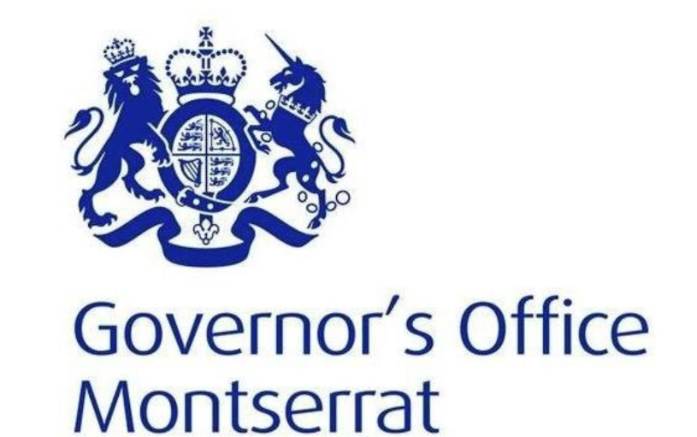 | “Marriage Licence Petition
We, the undersigned apply for a Marrige Licence under section 36 of the Marriage Act (Cap. 5.01) and in compliance with the requirements of the law state as follows:

PARTICULARS | APPLICANT |  |  |  |  |  | JOINT APPLICANT
Last Name(s) | …………………………. |  |  |  |  |  | …………………………
First and Middle Name(s) | …………………………. |  |  |  |  |  | …………………………
Age | ………………………….. |  |  |  |  |  | ……..………….………..
Date of Birth
  Day  ……… | Month  ………….. | Year  …………….
  Day  ……… | Month  ………….. | Year  …………….
Place of Birth | ………………………………. |  |  |  |  |  | …………………..…………...
Profession/ Occupation | ………………………………. |  |  |  |  |  | ……………………………….
Place of residence in Montserrat | ……………………..  …………………….. |  |  |  |  |  | ……………………..  ……………………..
Duration of residence in Montserrat – | I have been resident in Montserrat for at least three working days immediately preceding this application
Duration of residence in Montserrat – | Yes □ No □ |  |  |  |  |  | Yes □ No □
Place of residence outside Montserrat | ……………………..  …………………….. |  |  |  |  |  | ……………………..  ……………………..
Marital Status | Never married □  Divorced □  Widowed □ |  |  |  |  |  | Never married □  Divorced □  Widowed □
If Divorced | Country ………………  Date ………………….  Case No./Court File No. …………… |  |  |  |  |  | Country ………………  Date ………………….  Case No./Court File No. ……………
If Widowed | Name of deceased spouse  ………………………….  Date of death  ………………………… |  |  |  |  |  | Name of deceased spouse  ………………………….  Date of death  …………………………
Consent Required | Yes □ No □ |  |  |  |  |  | Yes □ No □
The consent of (name of consentee), (relationship to applicant), to the marriage is required and is supported by the requisite notarized consent required under the Marriage Act.

The consent of (name of consentee), (relationship to joint applicant), to the marriage is required and is supported by the requisite notarized consent required under the Marriage Act.

Marriage to be solemnized by:
Marriage Officer  Name of Marriage Officer …………………..  Location …………………………………….  Intended date of marriage …………………….. |  |  |  |  | Registrar-General  Name of Registrar-General ……..……………  Location …………………………………….  Intended date of marriage …………………….
I, (name of applicant) and I, (name of joint applicant) know of no impediment of kindred or alliance or other lawful cause to prevent the proposed marriage and have attached a sworn statement to this effect.

Date of application: ……………………………………….
Signature |  | ……………….…………….. (Insert name of applicant) |  |  |  | ……………….……………..  (Insert name of joint applicant)
We attach to this application form, in respect of each party:
⁮ an original birth certificate
⁮ a copy of the photograph page of the party’s valid passport or a copy of the party’s driver’s licence or national identification card
⁮ if a party has never been married, a certificate of non-marriage or other written proof of non-marriage from a Register Office or similar office responsible for the registration of marriages in a country where the party resides
⁮ if a party has been previously married, proof of the dissolution of the marriage
⁮ if a party is widowed, proof of marriage and proof of death of her husband or his wife
⁮ a sworn statement before a notary public, Justice of the Peace, Commissioner for Oaths, minister of religion, judge or Registrar of the High Court that the party believes that there is no impediment of kindred or alliance or any other lawful cause to prevent the proposed marriage
⁮ notarized consent of the person or persons whose consent to the marriage is required under the Marriage Act, if the party is under the age of eighteen years and is not a widow or widower
⁮ a receipt evidencing the payment of the fee payable for the grant of a licence to marry

For Official Use Only
Application Received by: |  |  | Date Received |  |  |  |  | Decision
□ Approved
□ Denied
Documents attached: |  |  | Applicant | Joint Applicant |  |  |  | Comments
- Original birth certificate |  |  | □ | □ |  |  |  | ”; and
- Copy of valid passport, driver’s licence or national identification card |  |  | □ | □ |  |  |  | ”; and
- Certificate of non-marriage/ other proof of non-marriage |  |  | □ | □ |  |  |  | ”; and
- Proof of the dissolution of the marriage |  |  | □ | □ |  |  |  | ”; and
- Proof of marriage and death husband/wife |  |  | □ | □ |  |  |  | ”; and
- Sworn Statement of no impediment of kindred or alliance or other lawful cause preventing marriage |  |  | □ | □ |  |  |  | ”; and
- Notarized Consent |  |  | □ | □ |  |  |  | ”; and
- Licence Fee Receipt |  |  | □ | □ |  |  |  | ”; and
- in Form C, by deleting “twenty one” and substituting “eighteen”.

Sgd. Charliena M. L. White
SPEAKER
Miss. Charliena M. L. White

Passed by the Legislative Assembly this 30th day of April, 2024.

Sgd. Adina Lee
CLERK OF THE LEGISLATIVE ASSEMBLY (Ag.)
Mrs. Adina Lee

