No. 5 of 2021 Eastern Caribbean Securities Regulatory MONTSERRAT 1
Commission Agreement Act 2021

M O N T S E R R A T

EASTERN CARIBBEAN SECURITIES REGULATORY COMMISSION AGREEMENT ACT 2021

No. 5 of 2021

ARRANGEMENT OF SECTIONS

SECTIONS
1. Short title and commencement
2. Interpretation
3. Acceptance of Agreement
4. Agreement to have force of law
5. Amendments to the Agreement
6. Penalties
SCHEDULE

MONTSERRAT 2 Eastern Caribbean Securities Regulatory No. 5 of 2021 Commission Agreement Act 2021

I ASSENT

Sgd. Andrew Pearce (Mr.)
GOVERNOR

DATE: 4 May 2021

M O N T S E R R A T

No. 5 of 2021

AN ACT to provide for the implementation of the Agreement establishing the Eastern Caribbean Securities Regulatory Commission and for related matters.

BE IT ENACTED by the Queen’s Most Excellent Majesty, by and with the advice and consent of the Legislative Assembly of Montserrat, and by the Authority of the same as follows:—
1. Short title and commencement
(1) This Act may be cited as the Eastern Caribbean Securities Regulatory Commission Agreement Act, 2021.
(2) This Act comes into force on a date fixed by the Governor acting on the advice of Cabinet, by Notice published in the Gazette.
2. Interpretation
In this Act—
“Agreement” means the Agreement establishing the Eastern Caribbean Securities Regulatory Commission made on the 24th day of November 2000, the text of which is set out in the Schedule, and any revisions to it; and

No. 5 of 2021 Eastern Caribbean Securities Regulatory MONTSERRAT 3
Commission Agreement Act 2021

“Article” means an Article of the Agreement.
3. Acceptance of Agreement
The Government of Montserrat hereby enters into, adopts and adheres to the Agreement.
4. Agreement to have force of law
The Agreement shall have the force of law in Montserrat from a date as the Governor acting on the advice of Cabinet, by Notice published in the Gazette, appoints for the coming into force of the Agreement.
5. Amendments to the Agreement
(1) Where an amendment in the Agreement is accepted by the Government of Montserrat, the Governor acting on the advice of Cabinet may, by Order published in the Gazette, amend the Schedule for the purpose of including the amendment.
(2) Where the Schedule is amended in accordance with this section, a reference in this Act or in any other enactment or in any instrument having effect under the enactment shall, unless the context otherwise requires, be construed as a reference to the amended Agreement as amended.
6. Penalties
A person who contravenes paragraph (1) of Article 24 commits a summary offence and is liable to a fine of five hundred dollars or to six months’ imprisonment.

MONTSERRAT 4 Eastern Caribbean Securities Regulatory No. 5 of 2021 Commission Agreement Act 2021
SCHEDULE
(Section 2)

EASTERN CARIBBEAN SECURITIES REGULATORY COMMISSION AGREEMENT

ARRANGEMENT OF ARTICLES

PRELIMINARY

Articles

1. Title
2. Interpretation

PART I

ESTABLISHMENT, PURPOSES, POWERS AND DUTIES OF THE COMMISSION

3. Establishment of the Commission
4. Purposes of the Commission
5. Powers of the Commission
6 Duties of the Commission
7. Place of Office and Establishment of Agencies
8. Address and Service of Documents
9. Protection of persons dealing with the Commission and its Agents
10. Custody and use of Common Seal
11. Official Seal

No. 5 of 2021 Eastern Caribbean Securities Regulatory MONTSERRAT 5
Commission Agreement Act 2021

PART II

MEMBERS OF THE COMMISSION

12 Composition of Commission
13. Chairperson, Deputy Chairperson and Chief Executive Officer
14. Appointment of Commissioners to be notified in Official Gazette
15. Term of office of Chairperson, Deputy Chairperson and other Commissioners
16. Disqualification for Approval
17. Vacation and Removal from Office of Commissioners
18. Meetings of Commission
19. Administration
20. Committees
21. Delegation
22. Disclosure of Interest
23. Staff
24. Confidentiality

PART III

FINANCIAL MATTERS

25. Funding
26. Reserve Fund
27. Financial Year and Estimates
28. Accounts
29. Auditors and Audit
30. Annual Report
MONTSERRAT 6 Eastern Caribbean Securities Regulatory No. 5 of 2021 Commission Agreement Act 2021

PART IV

MISCELLANEOUS

31. Consultation and Co-operation
32. Procedural By-Laws
33. Amendments
34. Disputes
35 Legal Personality, Immunities and Privileges
36. Accession
37. Signatories
38. Ratification
39. Entry into force

AGREEMENT ESTABLISHING THE
EASTERN CARIBBEAN SECURITIES REGULATORY COMMISSION

PREAMBLE
WHEREAS it is desired to promote the development of a regional securities market, the Eastern Caribbean Securities Market and to provide for the regulation of this regional securities market in the territories of the Participating Governments and to preserve and continue the Eastern Caribbean Securities Regulatory Commission (ECSRC) as an independent an autonomous regional regulatory body.

IT IS HEREBY AGREED as follows:

No. 5 of 2021 Eastern Caribbean Securities Regulatory MONTSERRAT 7
Commission Agreement Act 2021

PRELIMINARY
Article 1
Title
This Agreement may be cited as the Eastern Caribbean Securities Regulatory Commission Agreement, 2020.

Article 2
Interpretation

In this Agreement—
"Eastern Caribbean Central Bank Agreement, 1983" means the Agreement establishing the Eastern Caribbean Central Bank done at Port-of-Spain on the 5th day of July, 1983;
"Commission" means the Eastern Caribbean Securities Regulatory Commission (ECSRC) established under the Eastern Caribbean Securities Regulatory Commission Agreement 2000;
"Commissioner" means a member of the Commission;
"Central Bank" means the Eastern Caribbean Central Bank established under the Eastern Caribbean Central Bank Agreement, 1983;
“Currency Union” refers collectively to the member countries of Anguilla, Antigua and Barbuda, The Commonwealth of Dominica, Grenada, Montserrat, Saint Christopher and Nevis, Saint Lucia and Saint Vincent and the Grenadines which use the Eastern Caribbean currency as their official currency;
“foreign regulatory authority” means an authority in a foreign jurisdiction that exercises regulatory or supervisory functions over entities carrying on banking, insurance, securities or other financial services;
"licensee" means a person licensed under securities laws;

MONTSERRAT 8 Eastern Caribbean Securities Regulatory No. 5 of 2021 Commission Agreement Act 2021
“Monetary Council" means the Monetary Council established under Article 7 of the Eastern Caribbean Central Bank Agreement, 1983;
"member country" means a country of a Participating Government;
"Participating Government" means the government of a member country of the Currency Union;
"Securities laws" means the Securities Act and the ECCU Investments Funds Act.

PART I
ESTABLISHMENT, PURPOSES, POWERS
AND DUTIES OF THE COMMISSION

Article 3
Establishment of the Eastern Caribbean Securities Regulatory Commission

- The Eastern Caribbean Securities Regulatory Commission established under the Eastern Caribbean Securities Regulatory Commission Agreement 2000, is preserved and continued under the Eastern Caribbean Securities Regulatory Commission Agreement 2020.

- The Eastern Caribbean Securities Regulatory Commission (ECSRC) is be a body corporate having perpetual succession.

- The Commission may sue and be sued in its corporate name.

- The establishment of the Commission shall continue to take effect in accordance with the provisions of Article 39.

- Until the coming into force of this Agreement, the provisions of the Eastern Caribbean Securities Regulatory Commission Agreement 2000 shall continue to apply in a member country;

No. 5 of 2021 Eastern Caribbean Securities Regulatory MONTSERRAT 9
Commission Agreement Act 2021

- The provisions of the Eastern Caribbean Securities Regulatory Commission Agreement 2000 shall cease to apply in a member country which is a party to this Agreement, except to the extent that this Agreement provides for the continued application of the Eastern Caribbean Securities Regulatory Commission Agreement 2000.

Article 4
Purposes of the Commission

- The purposes of the Commission are -
(a) to license a person engaged in securities business and to monitor and supervise the conduct of such business by a licensee;
(b) to promote investor protection through promotion of the highest standards of professional and other activities within the securities market;
(c) to maintain effective compliance and enforcement programmes supported by adequate statutory powers;
(d) to promote the growth and development of the capital markets.

Article 5
Powers of the Commission

- For the attainment of its purposes the Commission may -

- formulate policies and rules for the fair, orderly and efficient operations of the securities industry and the capital markets;

- deal with such matters as may be referred to it by any person from time to time;

MONTSERRAT 10 Eastern Caribbean Securities Regulatory No. 5 of 2021 Commission Agreement Act 2021

- licence and regulate market participants in accordance with securities laws;

- monitor the capital and solvency risk of licensees that are entities, and compensation funds and take measures to protect the interest of investors of market participants in question;

- adopt measures to supervise and minimise any conflict of interest that may arise with respect to market participants;

- review, approve and regulate takeovers, amalgamations and all forms of business combinations in accordance with securities laws in all cases in which it considers it expedient or appropriate to do so;

- review the contents of prospectuses and issue receipts, and review any form of offering documents, solicitation, advertisement or announcement by which securities are proposed to be distributed, continuing disclosure documents, financials and annual reports;

- take enforcement action against any person for failing to comply with securities laws;

- recommend regulations to the Minister and formulate rules;

- formulate, prepare and publish notices, guidelines, bulletins and policies describing the views of the Commission regarding the interpretation, application, or enforcement of securities laws;

- make orders for the administration, and enforcement of securities laws;

- cooperate with other regulatory authorities, whether domestic and foreign;

- acquire and dispose of property of any description;

- make contracts or enter into other agreements;

No. 5 of 2021 Eastern Caribbean Securities Regulatory MONTSERRAT 11
Commission Agreement Act 2021

- receive and expend money;

- require the payment of fees;

- do all things, and take all actions, which may be necessary, expedient, incidental or conducive to the discharge of any of its functions and the exercise of its powers under securities laws;

- The Commission may, in writing, require a person to furnish it with such information as required for the exercise of its functions;

- A person that is required to furnish information to the Commission in accordance with paragraph (2) shall furnish the required information, within the time specified and verified in the manner specified by the Commission.

Article 6
Duties of the Commission

- The duties of the Commission are to -
(a) take all reasonable steps to ensure that any securities laws are complied with;
(b) license, supervise and regulate the activities of marketplaces and ancillary facilities;
(c) license, supervise and regulate investment funds and their service providers;
(d) license, supervise and regulate licensees, and their representatives and principals;
(e) set standards of competence for licensees whether by way of examination or otherwise;
(f) approve the rules of marketplaces and ancillary facilities;

MONTSERRAT 12 Eastern Caribbean Securities Regulatory No. 5 of 2021 Commission Agreement Act 2021
g) monitor and enforce rules for the conduct of business of licensees including suspension and revocation of licences in accordance with any securities laws;
(h) promote and encourage high standards of investor protection and integrity among licensees, and to encourage the promulgation by licensees of balanced and informed advice to their customers and to the general public;
(i) support the operation of an orderly, fair and properly informed securities market;
(j) regulate the manner of trading and the range of securities traded on marketplaces;
- take all reasonable steps to safeguard and protect the interests of investors in securities and to suppress illegal, dishonourable and improper practices in dealings in securities and in providing advice or other services relating to securities;
- foster timely, accurate, fair and efficient disclosure of information to the investing public and the capital markets;
- co-operate with and assist other regulatory authorities and law enforcement authorities;
- educate and promote an understanding by the public of the securities and the benefits, risks, and liabilities associated with investing in securities;
- cooperate with other relevant regulatory bodies to ensure compliance by market participants with the Proceeds of Crime Act and any other written law in relation to the prevention of money laundering and combating the financing of terrorism and proliferation of weapons of mass destruction;
- create and promote such conditions in the securities market as may be necessary, advisable or appropriate to ensure the orderly growth, regulation and development of the securities market and further the purposes of the securities laws and any other written law that is administered by the Commission;
No. 5 of 2021 Eastern Caribbean Securities Regulatory MONTSERRAT 13
Commission Agreement Act 2021

- assess, measure and evaluate risk exposure in the securities market and take action as required; and

- exercise and perform such other duties as may be conferred or imposed upon it.

Article 7
Place of Office and Establishment of Agencies

- The Commission shall have its principal office in one of the member countries as the Monetary Council may by majority vote determine;

- The Commission may establish agencies and may appoint agents in any member country and elsewhere.

Article 8
Address and Service of Documents

- The Commission shall at all times have a fixed address in one of the member countries for the service of documents on the Commission;

(2) All documents to be served on the Commission may be served by electronic means or by leaving the same at or by sending the same by registered post to the Commission at its fixed address;

(3) The address for service of documents on the Commission shall be published in the Official Gazette of each member country.
Article 9
Protection of persons dealing with the Commission and its Agents

(1) A person who deals with the Commission shall not be affected by any irregularity of procedure in connection with the authorization of the transaction by a meeting of the Commission or by the non-fulfillment of any condition imposed by this Agreement in connection with the transaction;
MONTSERRAT 14 Eastern Caribbean Securities Regulatory No. 5 of 2021 Commission Agreement Act 2021

(2) A person who deals with another person who is held out by the Commission as having authority to act on the Commission's behalf in connection with a transaction may treat the Commission as bound by the acts of the person done within the apparent authority of that person even though that person has not been authorized by the Commission to do those acts on its behalf so long as that person has no knowledge whether actual or constructive, that that other person has not been so authorized by the Commission;

Article 10
Custody and use of Common Seal

(1) The Commission shall have a Common Seal;

(2) The Common Seal of the Commission shall be kept in the custody of the Chairperson or Chief Executive Officer, as the Commission may determine;

(3) The Common Seal of the Commission shall be affixed to instruments in the presence of the Chairperson or in the Chairperson’s absence, the Deputy Chairperson or in the absence of the Chair person and Deputy Chairperson the Chief Executive Officer and General Counsel;

(4) All instruments made by the Commission other than those required by law to be under Seal and all decisions of the Commission may be signified under the hand of the Chairperson or the Deputy Chairperson.

Article 11
Official Seal

(1) The Commission shall have an Official Seal, which shall be a facsimile of its Common Seal, for use in any member country other than where the principal office of the Commission is situated, with the addition on its face of the name of every member country where it is to be used;

- The Official Seal when duly affixed to a document has the same effect as the Common Seal of the Commission;
No. 5 of 2021 Eastern Caribbean Securities Regulatory MONTSERRAT 15
Commission Agreement Act 2021

(3) The Commission may by writing under its Common Seal, authorize any person appointed for the purpose in a member country to affix the Official Seal to any deed or other document to which the Commission is a party in the member country;

(4) The person affixing the Official Seal shall certify in writing the date on which and the place at which it is affixed.

PART II

MEMBERS OF THE COMMISSION

Article 12
Composition of Commission

(1) The Commission shall consist of five (5) Commissioners to be appointed by the Monetary Council by majority vote.

(2) The appointments made under this Article shall comprise the following:
(a) two (2) Commissioners from persons nominated by the member countries;
- two (2) Commissioners from persons nominated by the Chambers of Industry and Commerce, the Institute of Chartered Accountants and the Bar Associations or from such other relevant professional bodies of the member countries; and
(c) one (1) Commissioner nominated by the Central Bank;

- Persons nominated as Commissioners shall be persons of recognised standing and experience in securities and related matters or in any one of the following areas:
MONTSERRAT 16 Eastern Caribbean Securities Regulatory No. 5 of 2021 Commission Agreement Act 2021
(a) law;
(b) accountancy;
(c) banking;
(d) economics;
(e) commerce and industry; or
(f) finance.
(4) The Commissioners shall be paid such remuneration as may be determined by the Monetary Council.

Article 13
Chairperson, Deputy Chairperson and Chief Executive Officer

(1) Two of the members of the Commission shall, in and by the terms of their respective appointments by the Monetary Council, be appointed as the Chairperson and Deputy Chairperson of the Commission.

(2) The Commission shall appoint a suitable person to serve as the Chief Executive Officer of the Commission.

Article 14
Appointment of Commissioners to be notified in the Gazette

The appointment of all Commissioners including the Chairperson and Deputy Chairperson and the termination of any such appointment shall be published by Notice in the Gazette of the member countries.

Article 15
Terms of Office of Chairperson, Deputy Chairperson and other Commissioners
No. 5 of 2021 Eastern Caribbean Securities Regulatory MONTSERRAT 17
Commission Agreement Act 2021

(1) The Chairperson of the Commission shall hold office for a period of five years from the date of appointment as a Commissioner;

(2) The Deputy Chairperson of the Commission shall hold office for the period as specified in the instrument of appointment;

(3) A Commissioner (other than the Chairperson and the Deputy Chairperson) shall, subject to this Article, hold office for a period of three years from the date of appointment as Commissioner: Except that such a Commissioner may be appointed for a period of less than three years so as to assist in providing continuity of experience as a Commissioner;

(4) On the expiry of the period of appointment a Commissioner shall be eligible for reappointment;

(5) A Commissioner appointed to fill a vacancy shall hold office for the unexpired term of the predecessor.

Article 16
Disqualifications for Appointment

(1) A person shall not be appointed or continue as Commissioner if he or she—

- is a licensee, an employee or senior officer of a licensee or self-regulatory organisation;

- directly or indirectly, as owner, security holder, director, senior officer, partner, employee or otherwise has a material pecuniary or proprietary interest in—
- a licensee;
- a self-regulatory organisation; or
- a reporting issuer;

MONTSERRAT 18 Eastern Caribbean Securities Regulatory No. 5 of 2021 Commission Agreement Act 2021

- is sentenced to imprisonment or is convicted of an offence involving fraud or dishonesty, whether in any of the member countries or any other country;

- is declared bankrupt in accordance with the laws of any member country or any other country;

- is a professional and is disqualified or suspended from practising his profession in any of the member countries or in any other country by an order of any competent authority made in respect of him personally;

- is deemed unfit to perform his functions because of illness or for any other reason;

- has been the senior officer of a company in the ten years immediately preceding—

- a winding-up order being made by a Court in respect of that company; or

- the date on which the company has been placed in receivership;

- has been a senior officer of a former licensee or self-regulatory organisation whose licence has been revoked, unless such revocation was due to its-

- amalgamation with another licensee; or

- voluntary winding-up; or

- has contravened any laws.

(2) For the purposes of subsection (1)(b), a pecuniary or proprietary interest is material where-

- it may reasonably be expected to have a significant influence on the ability of the member to make an unbiased decision; or

- the person has beneficial ownership of, or control or direction over—

No. 5 of 2021 Eastern Caribbean Securities Regulatory MONTSERRAT 19
Commission Agreement Act 2021

- ten per cent or more of the outstanding equity or voting securities of a person licenced under Part II, IV, V of the Securities Act, an investment fund or investment fund administrator under the Investment Funds Act; or

- five per cent or more of the outstanding equity or voting securities of a reporting issuer,
except as a trustee of a trust;

- If an interest referred to in subsection (1)(b) vests in a Commissioner by gift, will, succession or in any other manner for his own benefit, he shall-

- immediately after the vesting of the interest comes to his knowledge, disclose the interest in writing to the Commission; and

- within three months or as soon as practicable of the vesting of the interest coming to his knowledge either absolutely dispose of the interest or resign;

- A person who contravenes subsection (3) is liable on summary conviction to a fine of five hundred thousand dollars and imprisonment for two years.

Article 17
Vacation of and removal from office of Commissioners

(1) The office of a Commissioner is vacated—
(a) upon the death of the Commissioner;

(b) if the Commissioner is adjudged bankrupt;
(c) if the Commissioner is absent from three consecutive meetings of the Commission without its permission or reasonable excuse;

MONTSERRAT 20 Eastern Caribbean Securities Regulatory No. 5 of 2021 Commission Agreement Act 2021

(d) if the Commissioner is certified by a Medical Board or Tribunal or declared by a Court to be mentally or physically incapable of performing the duties of a Commissioner;
(e) if the Commissioner is convicted of fraud or any other offence involving dishonesty;
(f) at any time by the Commissioner resigning from office by letter sent to the Chairperson of the Monetary Council and copied to the Chief Executive Officer of the Commission; or
(g) if the Commissioner is disqualified under Article 16(1).

(2) Notice of any removal under paragraph (1) shall be given to the Government of the member territory or such other body by which the Commissioner was nominated and the Government or such other body shall within thirty days of such notice submit nominations to the Monetary Council for a replacement;

(3) The Commission may act notwithstanding a vacancy among its members or any disability affecting any Commissioner.

Article 18
Meetings of Commission

(1) Meetings of the Commission shall be held as often as may be necessary for the performance of its duties and in any event at least once every quarter, and such meetings shall be held at such places, times and days as the Commission may determine;

(2) Notice of all meetings shall be given to each Commissioner;

(3) The Chairperson of the Commission may at any time call a meeting of the Commission and shall call a special meeting to be held within seven days of the receipt of a written request for that purpose addressed to the Chairperson by not less than two Commissioners;
No. 5 of 2021 Eastern Caribbean Securities Regulatory MONTSERRAT 21
Commission Agreement Act 2021

(4) At a meeting of the Commission -
(a) the Chairperson of the Commission shall preside;
(b) if the Chairperson of the Commission is not present, the Deputy Chairperson shall preside; or
(c) if the Chairperson of the Commission or the Deputy Chairperson is not present, the members present shall choose one of their number to preside;

(5) The quorum for a meeting of the Commission is three (3) Commissioners;

(6) Every question for decision at a meeting of the Commission shall be determined by a majority of votes of the members present and, in the event that voting is equally divided, the Chairperson of the meeting shall have a casting vote;

(7) A Commissioner shall be deemed to be present at a meeting of the Commission or of a committee of the Commission if the Commissioner participates by telephone or other electronic means and all Commissioners participating in the meeting are able to hear each other;

(8) A resolution in writing signed by all the Commissioners entitled to receive notice of a meeting of the Commission or of a committee of the Commission shall be valid and effectual as if it had been passed in a meeting of the Commission or (as the case may be) a committee of the Commission duly convened and held and may consist of several documents in the like form each signed by one or more Commissioners;

- Minutes, in proper form, of each meeting of the Commission, or a committee of the Commission, shall be kept under the direction of the Chief Executive Officer;

- All decisions, resolutions, order, or rules made and legislation recommended by the Commission or a committee thereof, as the case may be, shall be recorded in the minutes;

MONTSERRAT 22 Eastern Caribbean Securities Regulatory No. 5 of 2021 Commission Agreement Act 2021

- The minutes shall be confirmed at the next meeting of the Commission, or the committee, as the case may be, and a copy of the minutes when prepared and confirmed shall, in the case of a committee, be forwarded to the Commission;

- The Monetary Council is entitled, upon request, to have access to the minutes of the Commission or a committee of the Commission, and to receive from the Commission a copy of any of those minutes;

Article 19
Administration

(1) The Commission shall organise and regulate its administration, procedure and business in such manner as it considers will best ensure the performance of its functions and the proper exercise of its powers.

(2) The Commission may make rules governing its own procedure and such rules are binding on the Commission.

Article 20
Committees

(1) The Commission may, in the exercise of its duties establish standing or special committees and may refer or assign to a committee any matter for consideration, inquiry or management by the Commission.

- The Commission may appoint a person to be a member of a committee whether that person is a member of the Commission or not, and may appoint a member of the committee to be the Chairperson, provided that where a member of the Commission has been appointed to serve on a committee that member shall be the Chairperson of the committee.

No. 5 of 2021 Eastern Caribbean Securities Regulatory MONTSERRAT 23
Commission Agreement Act 2021

- Any reference or assignment under paragraph (1) and every appointment under paragraph (2) may be withdrawn or revoked by the Commission at any time, and no such reference or assignment shall prevent the exercise by the Commission of any of its duties.

- Without prejudice to the generality of paragraph (1) and subject to paragraph (5), where any power or function which requires investigation, hearing, adjudication or decision which might lead to the taking of any disciplinary measure against any person or the imposition of any penalty or order for the payment of any money by or to any person, is by the Securities Act assigned to the Commission, such investigation or hearing may be conducted by a committee appointed under this section and shall be fully, duly and validly conducted as if conducted by the entire Commission.

(5) The Commission may by resolution, adopt the recommendations of a committee appointed under subsection (1).

(6) Subject to paragraph (2), a committee established under this Article may elect one of its members to be the Chairperson and, subject to any specific or general direction of the Commission, may regulate its own procedure and business.

(7) Meetings of a committee shall be held at such times and places as the Chairperson of that committee may determine or as the Commission may direct.

(8) Each committee shall keep minutes of its meetings in accordance with Article 18 (9) and shall keep the Commission informed of its activities.

Article 21
Delegation

(1) For the purposes of the administration of securities laws, the Commission may, by order delegate in writing, any responsibility, power or function conferred on it by securities laws to any—
- Commissioner;

MONTSERRAT 24 Eastern Caribbean Securities Regulatory No. 5 of 2021 Commission Agreement Act 2021

- Senior officer of the Commission;

- A body or authority approved by the Monetary Council;

- A committee established under Article 20; or

- Self-regulatory organisation licensed under the Securities Act or any other written law that is administered by the Commission;

(2) Notwithstanding paragraph (1), the Commission shall not delegate its powers to—
(a) make regulations;

(b) hear appeals under securities laws;

- The Commission may by Order published in the Gazette revoke a delegation.

(4) A delegation under this Article does not preclude the exercise by the Commission of any of the duties so delegated.

- All decisions made, and minutes of all meetings held by a delegate under paragraph (1), shall as soon as practicable be recorded in writing.

- A delegate shall immediately notify the Commission of every decision made by him.

- Any minutes recorded under paragraph (5) shall as soon as practicable be forwarded to the Commission.

- Subject to securities laws, a person aggrieved by a decision of a delegate may, within fourteen days of the decision, apply to the Commission for a review of that decision.

- For the purposes of this Article, “a senior officer of the Commission” means a person holding or acting in the office of-

- Chief executive officer;
No. 5 of 2021 Eastern Caribbean Securities Regulatory MONTSERRAT 25
Commission Agreement Act 2021

- Deputy chief executive officer; or
- General Counsel.

Article 22

Disclosure of Interest

(1) A Commissioner who is in any way interested, whether directly or indirectly, in any transaction or arrangement with the Commission or in which the Commission is interested or whose material, pecuniary or proprietary interest in a company, partnership, undertaking or other business is likely to be affected by a decision of the Commission shall disclose the nature of his or her interest at the first meeting of the Commission at which he is present after the relevant facts come to his knowledge;

(2) A disclosure under paragraph (1) shall be recorded in the minutes of the meeting and after the disclosure the Commissioner making it shall not vote on the matter and, unless the Commission otherwise directs, shall not be present or take part in the proceedings of any meeting at which the matter is being discussed or decided by the Commission;

(3) A Commissioner shall be treated as having an indirect interest in any transaction or arrangement with the Commission or in which the Commission is interested if he or she is a director, shareholder, trustee, agent or employee of the company or undertaking that is a party to the contract or proposed contract with the Commission or where his spouse, parent, child, step-child, brother or sister or the parent, child, step-child, brother or sister of his or her spouse holds an interest in that company or undertaking;

- For the purpose of this Article, a general notice given to the Commission by a Commissioner to the effect that he or she is a member of or otherwise associated with a specified company or undertaking and is to be regarded as interested in any contract which may after the date of the notice be made with that company or undertaking shall be deemed to be a sufficient declaration of interest in relation to any contract so made.

MONTSERRAT 26 Eastern Caribbean Securities Regulatory No. 5 of 2021 Commission Agreement Act 2021

Article 23
Staff

(1) The Commission may employ, on such terms and conditions as it thinks fit a Chief Executive Officer who shall not be a Commissioner;

(2) The Chief Executive Officer shall perform such functions as may be conferred on him by the Commission;

(3) The Chief Executive Officer is subject to the direction of the Commission and is responsible to the Commission for the execution of its policy and management of affairs;

(4) A person who is appointed Chief Executive Officer under this Agreement or any other written law that is administered by the Commission shall, immediately after the appointment, declare every interest he or she has in any security and thereafter he or she shall not, while holding office as Chief Executive Officer-

(a) participate directly or indirectly, in any securities market operation transaction in which he has a material interest and which is subject to regulation by the Commission pursuant to securities laws; or

(b) engage in any other business, vocation or employment other than that of serving as Chief Executive Officer;

(5) The Commission may appoint, hire or retain, on such terms and conditions as it may determine, an expert to assist it in any manner that it considers necessary;

- Where the Commission appoints an expert to advise it on the development of specific policies, regulations, or other regulatory proposals of the Commission or a self-regulatory organisation, the expert shall formulate and report his views to the Commission in writing and the Commission may, if it thinks fit, make it available to the public;

No. 5 of 2021 Eastern Caribbean Securities Regulatory MONTSERRAT 27
Commission Agreement Act 2021

- The Commission may employ, on such terms and conditions as it thinks fit, such professional, technical and other officers and such other staff as it may be necessary for the exercise and discharge of its duties.

Article 24
Confidentiality

- Subject to paragraph (2) a person shall not make use of or disclose any confidential information other than for the administration or enforcement of securities laws;

(2) Notwithstanding paragraph (1), any other written law, or rule of law, on a written request the Commission or any duly authorised person or entity may disclose the information referred to in paragraph (1)-
(a) pursuant to a court order; or
(b) to-
- a representative of the government of any of he member countries;
- a duly authorised representative of the Central Bank, the Financial Intelligence Unit or a regulatory agency in any of the member countries;

- an expert hired or retained by the Commission; or

- a duly authorised representative of a securities or foreign regulatory authority,

in connection with the administration and enforcement of securities laws, any other written law that is administered by the Commission or similar legislation of any foreign jurisdiction if the Commission is satisfied that the information will be treated as confidential by the person or agency to whom it is disclosed and used strictly for the purpose for which it is disclosed;

- Paragraph (1) applies to any person who receives information under paragraph (2);

- For the purpose of this Article, “confidential information” means any information obtained as a result of a person’s relationship with the
MONTSERRAT 28 Eastern Caribbean Securities Regulatory No. 5 of 2021 Commission Agreement Act 2021

- Commission in the course of his duties in the exercise of the Commission’s functions under securities laws but does not include information that is or has already been made available to the public;
- Every member, officer and employee of the Commission shall be required to take an oath of secrecy.

- The duty not to disclose information pursuant to paragraph (1)–

  - applies to persons both before and after they have terminated their employment with the Commission; and
  - includes the duty to maintain the confidentiality of any information received from a foreign regulator.

PART I11

FINANCIAL MATTERS

Article 25
Funding

The Commission shall be funded by—

(a) the payment to the Commission of any fees or other charges in relation to—

(i) an application to the Commission for any licence, authorization, approval, exemption, waiver or modification;
(ii) any duties exercised by the Commission or by a committee established by the Commission;
(iii) the approval of a prospectus;
(iv) the receipt and monitoring of the continuing disclosure obligations of issuers;

No. 5 of 2021 Eastern Caribbean Securities Regulatory MONTSERRAT 29
Commission Agreement Act 2021

(v) anything done in the performance of a function relating to take overs, amalgamations or other reorganizations;
(vi) any other matter for which provision is made under securities laws;

(b) the payment to the Commission of a levy, as may be prescribed, in respect of every purchase and sale of securities recorded by a securities exchange or notified under its rules;

(c) such sums of money or such other assets as may accrue to or vest in the Commission from time to time, whether in the course of the exercise of its duties or otherwise; and

(d) such sums as may be paid to the Commission from time to time by or on behalf of the Participating Governments with the approval of the Monetary Council, by way of appropriation or subvention.

Article 26
Reserve Fund

(1) The Commission may establish a Reserve Fund into which must be paid:

(a) fees, levies or any penalties imposed or charged under securities laws;

(b) any sums appropriated by a Participating Government for this purpose; and

(c) any other sums which the Commission with the approval of the Monetary Council may determine;

MONTSERRAT 30 Eastern Caribbean Securities Regulatory No. 5 of 2021 Commission Agreement Act 2021

(2) The Commission may withdraw any funds from the Reserve Fund for the purpose of exercising its duties under securities laws;

(3) The funds in the Reserve Fund may be invested by the Commission on such terms and conditions as may be determined by the Commission. Except that the Commission shall not invest its funds in securities offered by any person under its supervision or regulation;

(4) The Commission shall not make a disbursement from the Reserve Fund within the first five years of the establishment of the Reserve Fund.

Article 27
Financial Year and Estimates

(1) The financial year of the Commission shall begin on 1 April and end on 31 March in each year, or such other period as the Monetary Council may determine except that the first financial year of the Commission shall begin on the establishment of the Commission under Article 3 and end on the following 31 March or such other date as the Monetary Council may decide;

(2) The Commission shall not later than 31 December in each financial year or at least three months before the end of its financial year submit to the Monetary Council for its approval estimates of its income and expenditure for the next financial year;

(3) The Commission shall discharge its functions to ensure that its revenue is not less than sufficient to meet all sums properly chargeable to its revenue account;

(4) Any excess of the revenue of the Commission for any financial year over the sum properly chargeable to its revenue account for that year shall be applied by the Commission for the purposes of the Commission;

No. 5 of 2021 Eastern Caribbean Securities Regulatory MONTSERRAT 31
Commission Agreement Act 2021

(5) Where any deficit arises on the operations of the Commission or is budgeted for in the Estimates of expenditure of the Commission the Participating Governments shall provide a subvention to the Commission to meet the deficit in such proportion as may be determined by the Monetary Council.

Article 28
Accounts

(1) The Commission shall keep proper accounts and records of its transactions;

(2) The Commission shall, as soon as practicable after the end of each financial year, prepare a statement of the accounts of the Commission for the financial year including an income and expenditure account and balance sheet.

Article 29
Auditors and Audit

(1) The Commission shall, with the approval of the Monetary Council, appoint auditors;

(2) The Commission shall, as soon as practicable after the end of each financial year, submit the statement of accounts prepared for the year under Article 28 to the auditors for audit;

(3) The auditors shall prepare a report on the accounts and send the report to the Commission who shall, as soon as practicable after its receipt, send a copy of the report and a copy of the statement of accounts to the Monetary Council;

(4) The auditors shall include in the report—
(a) a statement whether, in their opinion, the income and expenditure account for the financial year to which the

MONTSERRAT 32 Eastern Caribbean Securities Regulatory No. 5 of 2021 Commission Agreement Act 2021

report relates give a true and fair view of the Commission's income and expenditure;
(b) a statement whether, in their opinion, the balance sheet for the financial year gives a true and fair view of the Commission's financial affairs at the end of that financial year;

(5) An auditor appointed by the Commission has a right of access at all reasonable times to the books, accounts, vouchers and other records of the Commission and is entitled to require from officers of the Commission such information and explanations as he considers necessary for the performance of his duties as auditor.

Article 30
Annual Report

(1) The Commission shall, not later than three months after the end of each financial year of the Commission, prepare and submit a report on its activities during the financial year to the Monetary Council;

(2) Subject to the confidentiality requirements of Article 24, the Monetary Council may at any time request the Commission to provide it with information concerning any matter relating to the duties of the Commission and the Commission shall provide the information requested within fourteen days of such request. All information submitted to the Monetary Council should be treated as confidential.

PART IV
MISCELLANEOUS

Article 31
Consultation and Co-operation

No. 5 of 2021 Eastern Caribbean Securities Regulatory MONTSERRAT 33
Commission Agreement Act 2021

(1) The Commission shall consult and co-operate with the Central Bank or any other agency in any member country that exercises regulatory authority under any enactment over a financial institution, insurance company or other body in order to minimise duplication of effort, to maximise the protection of investors and the interest of the public;

(2) On the request of a foreign regulatory authority, the Commission may provide assistance in accordance with this Article—

- if the authority making the request states that the purpose for the request is to assist the authority in conducting an investigation in order to determine whether any person or entity has violated, is violating, or is about to violate, any laws or rules relating to securities matters that the authority administers or enforces; and

- whether or not the facts stated in the request disclose a violation of any of the laws of a member country;

- Any assistance provided by the Commission under this Article shall be without prejudice to any investigation or examination which the Commission may carry out under securities laws, regardless of whether the Commission utilised any power given to it for the purposes of providing such assistance;

- The provisions of this Article shall have effect notwithstanding anything contained in any other law providing for assistance by a member country, or any Government department or agency, to a foreign State or agency;

- The assistance which may be provided for the purposes of this Article is the disclosure of any information which the Commission has in its possession or is able to obtain under any of the powers given to it by securities laws;

- Any request for assistance received under securities laws from a foreign regulatory authority and the information or other assistance obtained or
MONTSERRAT 34 Eastern Caribbean Securities Regulatory No. 5 of 2021 Commission Agreement Act 2021

- provided pursuant to such a request is subject to the confidentiality requirements of Article 24;

- Paragraph (6) shall not apply to any disclosure ordered by a court-
- for the purpose of any civil proceedings in relation to any matter under securities laws; or
- for the purpose of any criminal proceedings;

- Upon being ordered to make a disclosure referred to in paragraph (7), the Commission shall immediately notify the foreign regulatory authority concerned, of the order;

(9) The Commission may co-operate in the work of national, regional or international organisations on matters involving the regulation of securities markets.

Article 32
Procedural By-Laws

(1) The Commission may make procedural by-laws for—
(a) the calling of and conduct of business at meetings of the Commission;
(b) procedures for the initiation and holding of hearings by the Commission in accordance with securities laws;
(c) the procedure for appeals and review of orders of its delegates and self-regulatory organizations;
(d) with the approval of the Monetary Council, establishing a code of conduct governing the activities of Commissioners and the officers and employees of the Commission in order to avoid conflicts of interest and other practices that the Commission considers undesirable;
No. 5 of 2021 Eastern Caribbean Securities Regulatory MONTSERRAT 35
Commission Agreement Act 2021
(e) any other matter relating to the organization, procedure, administration or practice of the Commission;
(2) As soon as practicable after the making of any by-laws, the Commission shall submit a copy of same to the Monetary Council.

Article 33
Amendments

(1) An amendment to this Agreement may be proposed to the Monetary Council by the Commission and shall be effective when it is agreed to by all the Participating Governments;

(2) All amendments to the Agreement shall be published in the official Gazette of member countries.
Article 34
Disputes

(1) Any dispute between the Participating Governments concerning this Agreement or between the Commission and a participating Government, shall be submitted to arbitration by a tribunal of arbitrators appointed pursuant to paragraph (2);

(2) If the dispute is between only two parties, each party shall be entitled to appoint one arbitrator, and the two parties shall together appoint a third arbitrator, who shall be the Chairperson of the tribunal;

- If the dispute is between three or more parties, each party shall be entitled to appoint one arbitrator and all the parties shall together appoint an additional arbitrator, who shall be the Chairperson of the tribunal;

- If, within thirty days of receipt of the request for arbitration, any party has not appointed an arbitrator or if within thirty days of the appointment of the arbitrators the parties have not appointed the third arbitrator or, as the case may be, the additional arbitrator, any party to the dispute may request the Chief Justice of the Eastern Caribbean States Supreme Court, or such other person of
MONTSERRAT 36 Eastern Caribbean Securities Regulatory No. 5 of 2021 Commission Agreement Act 2021

authority as may be prescribed by the Monetary Council to make the required appointment;

- The procedure of the tribunal shall be fixed by the arbitrators, but the Chairperson of the tribunal shall have full power to settle all questions of procedure in any case of disagreement with respect to;

- A majority vote of the arbitrators shall be sufficient to reach a decision which shall be final and binding upon the parties;

- The Chairperson of the tribunal shall be entitled to vote, and in the event of a tie, the Chairperson shall have a casting vote.

Article 35
Legal Personality, Immunities and Privileges

- The Commission shall enjoy legal personality;

- To enable the Commission to fulfil the functions with which it is entrusted, the legal capacity, immunities and privileges set forth in this Article shall be accorded to the Commission in the territory of each Participating Government;

- The Commission, its property and its assets, wherever located and by whomsoever held, shall enjoy immunity from every form of judicial process except to the extent that it expressly waives its immunity for the purpose of any proceedings by the terms of any contract;

- Property and assets of the Commission shall be immune from search, requisition, confiscation, expropriation or any other form of seizure;

- The archives of the Commission shall be inviolable;

No. 5 of 2021 Eastern Caribbean Securities Regulatory MONTSERRAT 37
Commission Agreement Act 2021

- To the extent necessary to carry out the provisions of this Agreement, all property and assets of the Commission shall be free from restrictions, regulations, control and moratoria of any nature;

- The official communications of the Commission shall be accorded by Participating Governments the same treatment as the official communications of other Participating Governments;

- The Commissioners, officers and employees of the Commission:
  - shall be immune from legal process with respect to acts done by them in good faith in the performance of a duty or in the exercise of a function or power of the Commission under this Act or any other written law that is administered by the Commission;

  - not being local nationals, shall be granted the same immunities from immigration restrictions, alien registration requirements and national service obligations and the same facilities as regards exchanges restrictions as are accorded by Participating Governments to the representatives, officials and employees of comparable rank of other Participating Governments;

  - shall be granted the same treatment in respect of travelling facilities as is accorded by Participating Governments to representatives, officials and employees of comparable rank of other Participating Governments;

- The Commission, its assets, property, income and its business, shall be immune from all taxation and from all customs duties in respect of goods acquired by, or service rendered to it for its own use. The Commission shall also be immune from liability for the collection or payment of any tax duty in respect thereof except when it resells a good acquired by it to a member of the public;

- No tax shall be levied on or in respect of salaries or emoluments, including pensions and gratuities, paid by the Commission to the Commissioners, officers and employees of the Commission;

MONTSERRAT 38 Eastern Caribbean Securities Regulatory No. 5 of 2021 Commission Agreement Act 2021

- No civil or criminal liability shall attach to the Commission, or a Commissioner, Executive Director, an employee or an agent of the Commission for an act done in good faith in the performance of a duty or in the exercise of a function or power of the Commission under securities laws.

Article 36
Accession

(1) After the entry into force of this Agreement, a territory which is not a signatory to this Agreement may in the discretion of the Monetary Council be permitted to accede to this Agreement on such terms and conditions as the Monetary Council may determine;

(2) Any such territory shall deposit on or before a date appointed by the Monetary Council an Instrument of Accession with the Commission which shall signify such deposit and the date thereof to the parties to this Agreement.

Article 37
Signatories

This Agreement shall be open for signature by any Participating Government.

Article 38
Ratification

This Agreement shall be subject to ratification by the signatory Participating Governments in accordance with their respective constitutional procedures. Instruments of Ratification shall be deposited with the Director General of the Organisation of Eastern Caribbean States who shall transmit certified copies to each Participating Government.

No. 5 of 2021 Eastern Caribbean Securities Regulatory MONTSERRAT 39
Commission Agreement Act 2021

Article 39
Entry into force

This Agreement shall enter into force upon the deposit of five Instruments of Ratification and Participating Governments undertake to take all steps necessary for the implementation of this Agreement.

IN WITNESS WHEREOF the representatives of the Participating Governments being duly authorised in their behalf, have signed this Agreement.

DONE AT Basseterre, St Kitts and Nevis this 14th day of February, 2020.

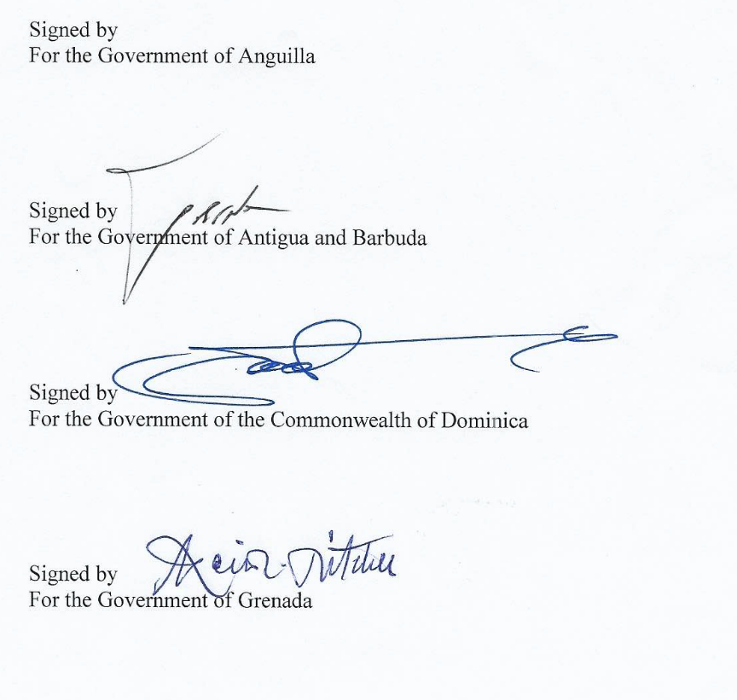

MONTSERRAT 40 Eastern Caribbean Securities Regulatory No. 5 of 2021 Commission Agreement Act 2021

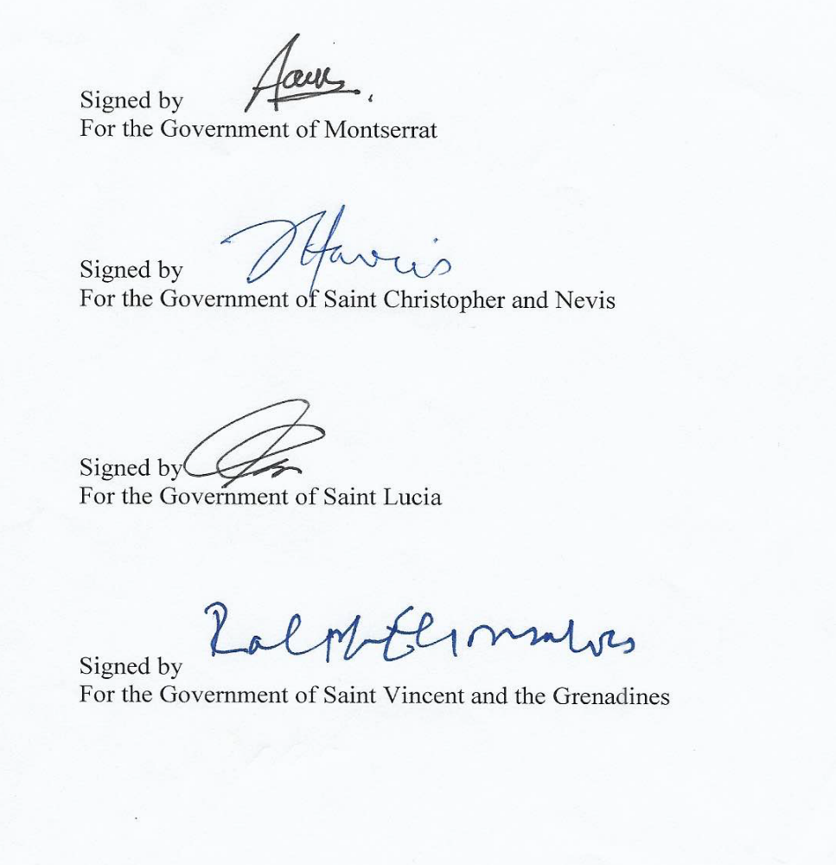

Sgd. Charliena M. L. White (Miss.)
SPEAKER

Passed by the Legislative Assembly this 27th day of April, 2021.

Sgd. Shivonne White (Mrs.)
CLERK OF THE LEGISLATIVE ASSEMBLY (Ag.)

